**23CSE111**

**OBJECT ORIENTED PROGRAMMING**

**LAB REPORT**



**Department of Computer Science Engineering**   **Amrita School of Computing**

**Amrita Vishwa Vidyapeetham, Amaravati Campus**

**Name: K . Yagna Suvidh**

**Roll No: 24136**

**Verified By :**

|  |  |  |  |  |
| --- | --- | --- | --- | --- |
| **S.NO** | **Experiment** | **Page No** | **Remarks** | **Signature** |
| **1** | **Installation Process of JDK** | **3-4** |  |  |
| **2** | **Simple java program for printing basic details of student** | **5** |  |  |
|  |  |  |  |  |
|  |  |  |  |  |

**INDEX**

# WEEK-1

1. **Process of Installing JDK (Java Development Kit)**

**Installing JDK (Java Development Kit):**

* 1. **Download JDK:**
* Go to the Oracle JDK download page in google and click on JDK-21 version which is Long term support (LTS) version.
* Click the download link as your operating system (Windows, macOS, or Linux).
  1. **Install JDK:**
* Once downloaded, run the installer.
* Follow the given instructions and keep clicking "Next" until it is done.
  1. **Set Environment Variables (Windows):**
* Open file explorer, then right click on This PC next select on properties then it will take you to the settings app then click on advanced system settings and then click on **Environment Variables**.
* Click on path and new under **System Variables**:

**Variable value:** The folder address where JDK is installed (like

C:\Program Files\Java\jdk-21\bin)

* Find Path under **System Variables**, click **New**, and add the path of the jdk-21(C:\Program Files\Java\jdk-21\bin)

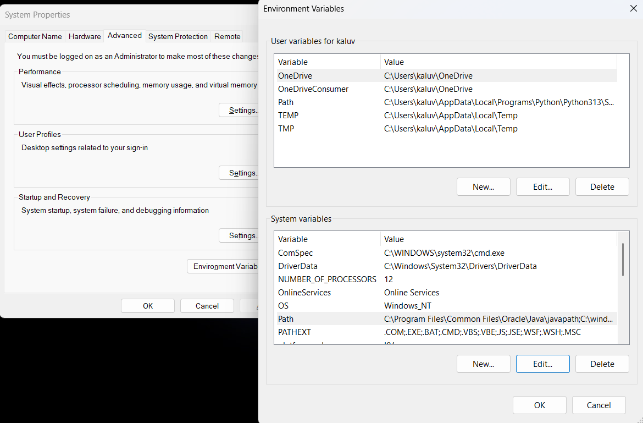

**Checking JDK Version: -**

* 1. **Open Command Prompt:**
* Presswin+R, typecmd, and press Enter.
  1. **Check Version:**
* Type java -version and press Enter.
* Type javac --version and press Enter.

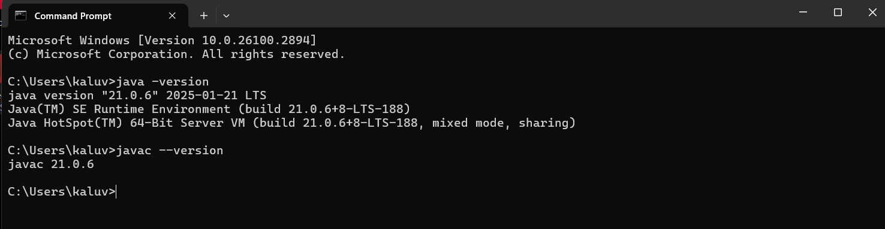

1. **Simple Java Program for printing Name, Class, Roll No, of a Student**

Write your code in Notepad and execute it in cmd prompt

**CODE: -**

class Main

{

public static void main(String[] args)

{

System.out.println("Name:K.Suvidh");

System.out.println("Class:CSE-B");

System.out.println("Roll No:24136");

}

}

**Output: -**

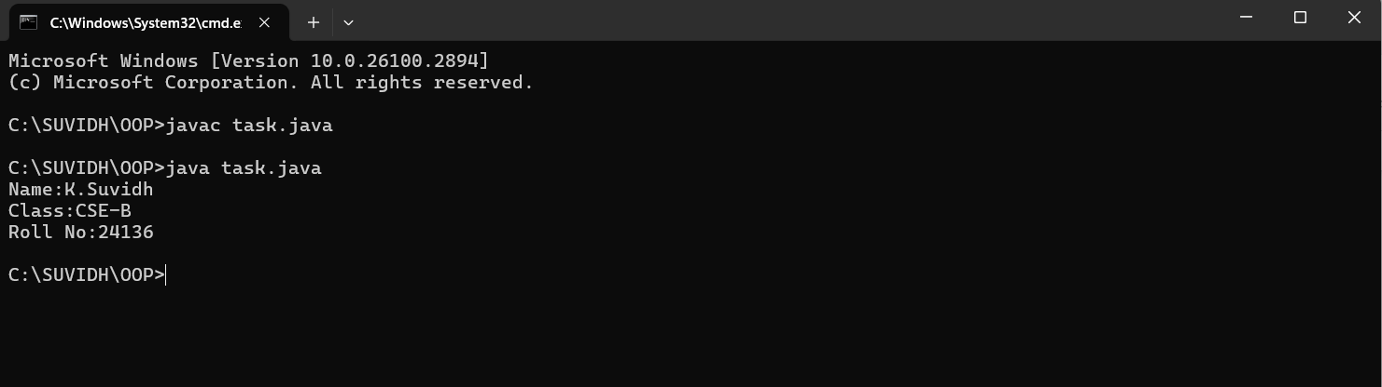

**WEEK-2**

**1) AIM:**

**Write a simple program to calculate factorial of a number and read the input from user**

**PROGRAM :**

class Test {

static int factorial(int n)

{

int res = 1, i;

for (i = 2; i <= n; i++)

res *= i;

return res;

}

public static void main(String[] args)

{

int num = 5;

System.out.println("Factorial of " + num + " is "

+ factorial(5));

}

}

**OUTPUT :**

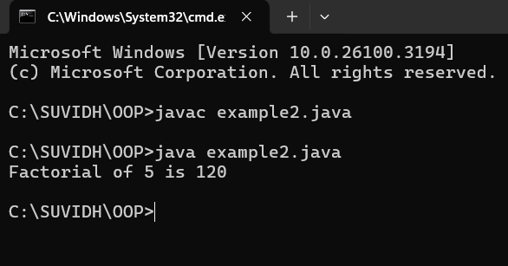

|  |  |  |  |
| --- | --- | --- | --- |
| **S.no** | **Error type** | **Reason for error** | **Rectification** |
| 1 | Undeclared variable error | Missing variable | Variable declared |
| 2 | Missing import statement | Not importing packages | Packages imported |
| 3 | Logical error | Wrong formula | Formula rectified |

**2) AIM : Simple Java Program for finding simple interest by taking input from**

**PROGRAM :**

import java.util.Scanner;

class simple {

public static void main(String[] args) {

Scanner input = new Scanner(System.in);

System.out.print("Enter p :");

int p = input.nextInt();

System.out.print("Enter t :");

int t = input.nextInt();

System.out.print("Enter r :");

int r = input.nextInt();

System.out.println("The amount is:" + (p*t*r)/100);

}

}

**OUTPUT :**

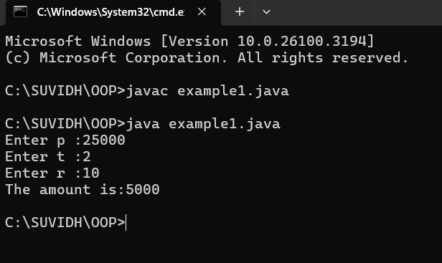

**ERROR :**

|  |  |  |  |
| --- | --- | --- | --- |
| **S.No** | **Error type** | **Reason for error** | **rectification** |
| 1 | Runtime error | Incorrect path | Copied correct path |
| 2 | Syntax error | { missing | { added |
| 3 | Logical error | Wrong formula | Formula rectified |

**3) AIM : Write a program to to calculate the fibonacii sequence and take the input from user**

**PROGRAM :**

import java.util.*;

class fibo

{

public static void main(String args[])

{

Scanner sc = new Scanner(System.in);

int num;

int f3;

int f1 = 0;

int f2 = 1;

int i = 2;

System.out.print("Enter a number:");

num = sc.nextInt();

System.out.println(f1);

System.out.println(f2);

while(i<num)

{

f3 = f1+f2;

f1 = f2;

f2 = f3;

System.out.println(f3);

i = i+1;

}

}

}

**OUTPUT :**

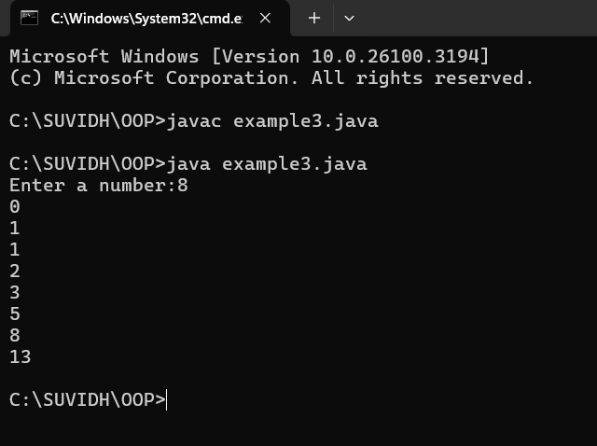

**ERROR :**

|  |  |  |  |
| --- | --- | --- | --- |
| **S.no** | **Error type** | **Reason for error** | **Rectification** |
| 1 | Logical error | Incorrect formula | Formula rectified |
| 2 | Run-time error | Incorrect path | Added correct path |

**4) AIM : Write a java program to find area of triangle using heron’s formula and area of triangle**

**PROGRAM :**

import java.util.Scanner;

class Area {

public static void main(String args[]) {

Scanner input= new Scanner(System.in);

System.out.print("Enter the length of side a: ");

double a = input.nextDouble();

System.out.print("Enter the length of side b: ");

double b = input.nextDouble();

System.out.print("Enter the length of side c: ");

double c = input.nextDouble();

double s = (a + b + c) / 2;

double area = Math.sqrt(s * (s - a) * (s - b) * (s - c));

System.out.println("The permeter of triangle is:" + s);

System.out.printf("The area of the triangle is:" + area);

}

}

**OUTPUT :**

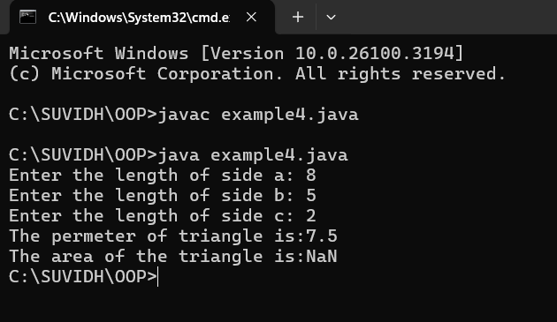

**ERRORS :**

|  |  |  |  |
| --- | --- | --- | --- |
| **S no** | **Error type** | **Reason for error** | **Rectification** |
| 1 | Syntax error | Semicolon missing | Semi colon added |
| 2 | Missing Scanner | Creating scanner input | Scanner added |

**5) AIM : Write a java program to convert temperature from Celsius to Fahrenheit**

**PROGRAM :**

class celsiustofahrenheit {

    public static void main(String[] args)

    {

        double celsius = 10.0, fahrenheit = 0.0;

        fahrenheit = (celsius * 1.8) + 32;

        System.out.println(

            " value of temperature in fahrenheit:"

            + fahrenheit);

    }

}

**OUTPUT :**

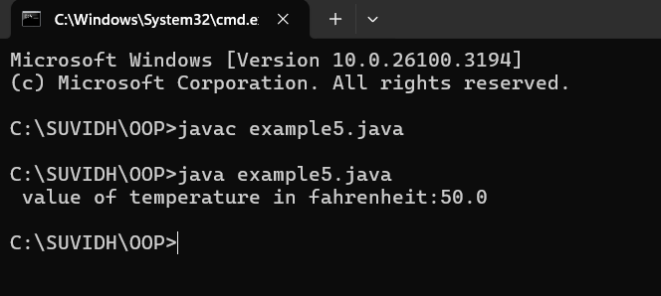

**ERRORS :**

|  |  |  |  |
| --- | --- | --- | --- |
| **S.No** | **Error type** | **Reason for error** | **Rectification** |
| 1 | Runtime error | Incorrect path selection | Correct path added |
| 2 | Logical error | Incorrect logic | Correct logic |

**WEEK-3**

1. **AIM :**

**Write a java program with following instructions**

1. **Create a class with name car**
2. **Create four attributes named, car colour, car brand , fuel type , mileage.**
3. **Create 3 methods named start , stop, service .**
4. **Create 3 objects named c1,c2,c3**
5. **Create a constructor with parameters , car colour , car brand , fuel type and mileage.**

**PROGRAM :**

class car {

//ATTRIBUTES

String car_brand;

String car_colour;

String fuel_type;

int mileage;

//CONSTRUCTORS

public car(String car_brand,String car_colour,String fuel_type,int mileage){

this.car_brand = car_brand;

this.car_colour = car_colour;

this.fuel_type = fuel_type;

this.mileage = mileage;

}

//METHODS

public void start() {

System.out.println("CAR IS STARTED");

}

public void stop() {

System.out.println("CAR IS STOPPED");

}

public void service() {

System.out.println("CAR IS I SERVICE");

}

public void car_details() {

System.out.println("CAR BRAND IS :" + car_brand);

System.out.println("CAR COLOUR IS :" + car_colour);

System.out.println("CAR FUEL TYPE IS :" + fuel_type);

System.out.println("CAR MILEAGE IS :" + mileage);

}

//MAIN PROGRAM

public static void main(String[] args) {

// CREATING OBJECTS FOR CLASS CAR

car c1 = new car("MCLAREN","GREEN","PETROL",12);

car c2 = new car("FERRARI","RED","PETROL",18);

car c3 = new car("LAMBORGHINI","ORANGE","PETROL",20);

//CALLING METHODS

c1.car_details();

System.out.println(" ");

c2.car_details();

System.out.println(" ");

c3.car_details();

}

}

**CLASS DIAGRAM :**

|  |
| --- |
| **CAR** |
| car_brand : String  car_colour : String  fuel_type : String  mileage : int |
| + car (String, String, String,int)  +start() : void  +stop() : void  +service : void  + car_details : void |

**OUTPUT :**

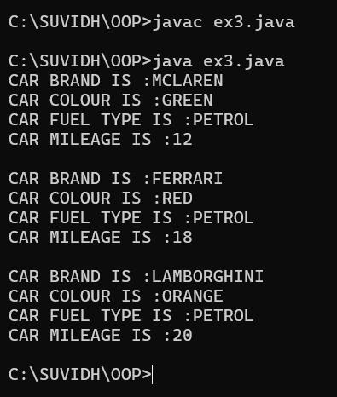

**ERRORS:**

|  |  |  |  |
| --- | --- | --- | --- |
| **S.No** | **Error type** | **Reason for error** | **Rectification** |
| 1 | Runtime error | Incorrect symbol in main program | { symbol is added |
| 2 | Logical error | Incorrect logic | Correct logic |

**4) AIM :**

**create a class named bankaccount with method deposit and with draw where the deposit method should accepts a parameter and when this method is called the deposited amount should be current balance .In addition to that when a withdraw method is called it has to verify whether withdraw amount is less than the current balance .If not display a message saying insufficient funds.Use the constructer to display the details of the customer (Customer name,account number , IFSC,branch) .Also create two customer objects c1,c2**

**PROGRAM :**

class bank {

    String name;

    String number;

    String IFSC;

    String branch;

    int balance;

//CONSTRUCTORS

public bank(String name, String number, String IFSC, String branch, int balance) {

    this.name = name;

    this.number = number;

    this.IFSC = IFSC;

    this.branch = branch;

    this.balance = balance;

}

//METHODS

public void bank_details() {

        System.out.println("Customer Name: " + name);

        System.out.println("Account Number: " + number);

        System.out.println("IFSC Code: " + IFSC);

        System.out.println("Branch: " + branch);

        System.out.println("Current Balance: "+ balance);

    }

//METHOD FOR DEPOSIT

public void deposit(int amount) {

    if (amount >0) {

    balance += amount;

    System.out.println("Total balance is :" + balance);

    } else {

    System.out.println("ERROR");

    }

}

//METHOD FOR WITHDRAWAL

public void withdrawal(int amount) {

    if (amount < balance) {

        balance -= amount;

        System.out.println("WITHDRAW AMOUNT IS:" + amount);

        System.out.println("UPDATED BALANCE IS: " + balance);

        } else {

            System.out.println("INSUFFICIENT BALANCE");

        }

    }

//MAIN FUNCTION

public static void main(String[] args) {

    //CREATING OBJECTS FOR CLASS BANK

    bank c1 = new bank("Rahul", "1234567890", "SBI1997","GUNTUR",0);

    bank c2 = new bank("Iyer", "1234567890", "SBI1996","GUNTUR",0);

    //CALLING METHODS

    //CUSTOMER 1 DETAILS

    System.out.println("CUSTOMER 1 DETAILS");

    System.out.println("    ");

    c1.bank_details();

    System.out.println("    ");

    System.out.println("CUSTOMER 1 DEPOSIT");

    c1.deposit(1000);

    System.out.println("    ");

    System.out.println("CUSTOMER 1 WITHDRAW");

    c1.withdrawal(500);

    System.out.println("    ");

    System.out.println("    ");

    //CUSTOMER 2 DETAILS

    System.out.println("CUSTOMER 2 DETAILS");

    System.out.println("    ");

    c2.bank_details();

    System.out.println("    ");

    System.out.println("CUSTOMER 2 DEPOSIT");

    c2.deposit(5000);

    System.out.println("    ");

    System.out.println("CUSTOMER 2 WITHDRAW");

    c2.withdrawal(600);

}

}

**CLASS DIAGRAM :**

|  |
| --- |
| bank |
| name:String  number:String  IFSC:String  branch:String  balance:int |
| bank(name:String , number:String, IFSC:String, +branch:String, balance:int)  +bank_details():void  +deposit(amount:int):void  +withdrawl(amount:int):void |

**OUTPUT :**

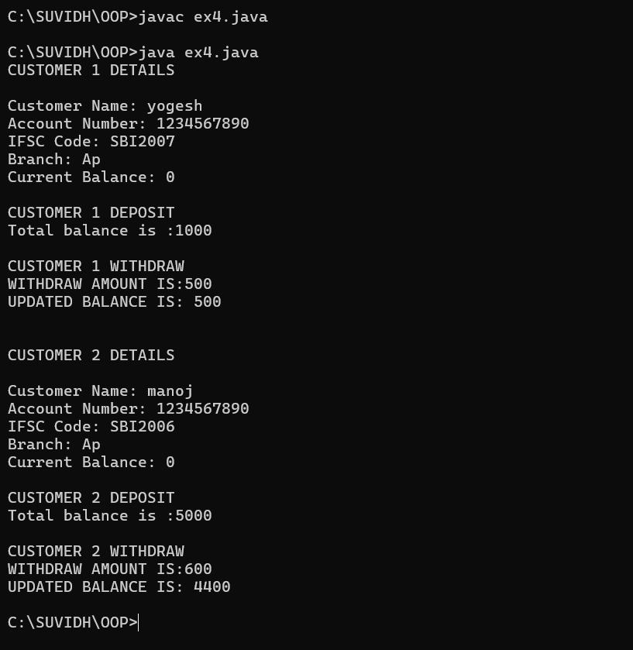

**ERRORS:**

|  |  |  |  |
| --- | --- | --- | --- |
| **S.No** | **Error type** | **Reason for error** | **Rectification** |
| 1 | syntax error | Forgot to keep main word in main program | Main is added |
| 2 | Logical error | Incorrect logic | Correct logic |

**WEEK-4**

1. **AIM : Write a java program with class named book the class should contain various attributes such as title ,author, year of publication .It should also contain a constructor with parameters with initializes title ,author and year of publication . create a method which displays the details of the book (display the details of two book i.e, create two books and objects with details).**

**PROGRAM:**

class book {

    String title;

    String author;

    int year;

//CONSTRUCTORS

public book(String title, String author, int year) {

    this.title = title;

    this.author = author;

    this.year = year;

}

//METHODS

public void details() {

    System.out.println("Title: " + title);

    System.out.println("Author :" + author);

    System.out.println("year of publication: " + year);

}

//MAIN FUNCTION

public static void main(String[] args) {

    //CREATING OBJECTS

    book b1 = new book("OPERATING SYSTEMS", "Galvin & Gange", 1997);

    book b2 = new book("DATABASE SYSTEMS", "Ramez Elmasri", 2004);

    //CALLING METHODS

    System.out.println("BOOK 1 DETAILS");

    System.out.println("    ");

    b1.details();

 System.out.println("    ");

    System.out.println("BOOK 2 DETAILS");

 System.out.println("    ");

    System.out.println("    ");

    b2.details();

}

}

**CLASS DIAGRAM :**

|  |
| --- |
| book |
| title : String  author : String  year : int |
| + book(title: String, author: String, year: int)  + details(): void |

**OUTPUT :**

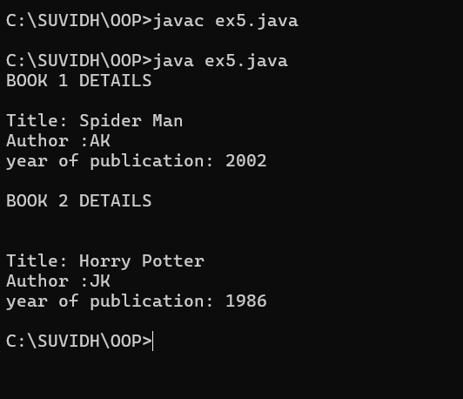

**ERRORS :**

|  |  |  |  |
| --- | --- | --- | --- |
| **S.No** | **Error type** | **Reason for error** | **Rectification** |
| 1 | syntax error | Forgot to keep }  At last | } is added |
| 2 | Logical error | Incorrect logic | Correct logic |

1. **AIM : write a java program to create a class named myclass with a static variable count of int type and initialize to zero and a constant variable pie of double data type ,initialize to 3.1415 as attributes of that class now define a constructor for my class that increments the count variables each time an object of my class is created variable each time an object of myclass is created. Finally print the final values of count and pie variables.**

**PROGRAM :**

class MyClass {

    static int count = 0;

    final double PIE = 3.1415;

//CONSTRUCTORS

public MyClass() {

        count++;

    }

//MAIN FUNCTION

    public static void main(String[] args) {

        //CREATING OBJECTS

        MyClass obj1 = new MyClass();

        MyClass obj2 = new MyClass();

        MyClass obj3 = new MyClass();

        //PRINTING COUNT

        System.out.println("Final count value: " + count);

        System.out.println("PIE constant value: " + obj1.PIE);

    }

}

**CLASS DIAGRAM :**

|  |
| --- |
| Myclass |
| Count : int  PIE : double |
| +Myclass() |

**OUTPUT :**

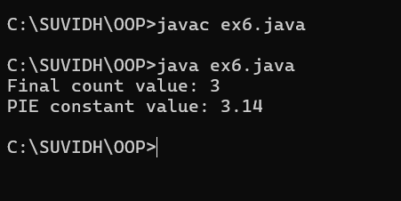

**ERRORS:**

|  |  |  |  |
| --- | --- | --- | --- |
| **S.No** | **Error type** | **Reason for error** | **Rectification** |
| 1 | syntax error | String forgot in main function | String is added |
| 2 | Logical error | Incorrect logic | Correct logic |